Project Design Phase-II
Data Flow Diagram & User Stories

Date | 9 July 2026
Team ID
Project Name | ShopEZ
Maximum Marks | 4 Marks

Data Flow Diagrams:

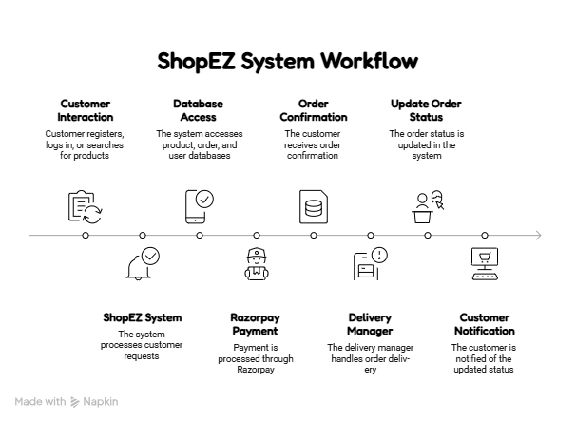

Data Flow Diagram Description

· Customer registers or logs into the ShopEZ application.
· The system validates user credentials using the authentication module.
· Customers browse, search, and view product details.
· Product information is retrieved from the MongoDB database.
· Customers add products to the cart or wishlist.
· During checkout, order details are processed by the backend.
· Razorpay securely processes the online payment.
· After successful payment, the order is stored in the database.
· Sellers receive new order details and manage inventory.
· Delivery managers update the shipment status.
· Administrators manage users, products, categories, and orders.
· Customers can track order status and view order history through the application.

User Stories

User Type | Epic | User Story No. | User Story | Acceptance Criteria | Priority | Release
Customer | Authentication | US-01 | As a customer, I can register for a new account. | User account is created successfully. | High | Sprint-1
Customer | Authentication | US-02 | As a customer, I can log in using my email and password. | User is redirected to the home page after login. | High | Sprint-1
Customer | Product Browsing | US-03 | As a customer, I can browse products by category. | Products are displayed correctly. | High | Sprint-2
Customer | Search | US-04 | As a customer, I can search for products. | Matching products are displayed. | High | Sprint-2
Customer | Cart | US-05 | As a customer, I can add products to my cart. | Selected product is added to the cart. | High | Sprint-3
Customer | Wishlist | US-06 | As a customer, I can save products to my wishlist. | Product appears in wishlist. | Medium | Sprint-3
Customer | Checkout | US-07 | As a customer, I can place an order using Razorpay. | Order is placed after successful payment. | High | Sprint-3
Seller | Product Management | US-08 | As a seller, I can add and update products. | Product details are saved successfully. | High | Sprint-4
Seller | Inventory | US-09 | As a seller, I can manage product inventory. | Stock quantity is updated correctly. | High | Sprint-4
Delivery Manager | Delivery | US-10 | As a delivery manager, I can update delivery status. | Updated status is visible to the customer. | Medium | Sprint-5
Administrator | User Management | US-11 | As an administrator, I can manage users. | User information is updated successfully. | High | Sprint-5
Administrator | Category Management | US-12 | As an administrator, I can manage product categories. | Categories are added, edited, or deleted successfully. | High | Sprint-5
Administrator | Order Monitoring | US-13 | As an administrator, I can monitor all orders. | Order details are displayed correctly. | Medium | Sprint-5

